Week 2
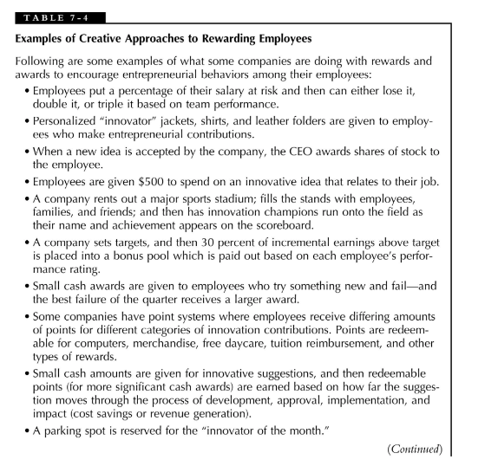
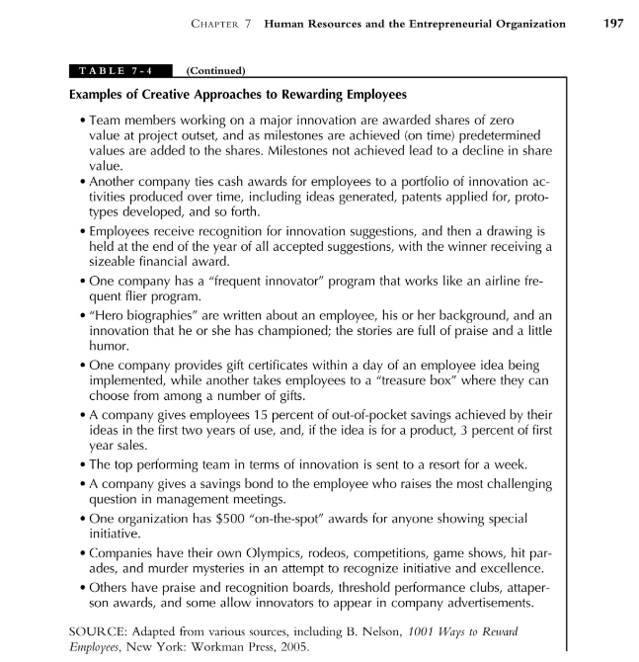
2. For Table 7-4, identify what kind of motivation is satisfied by each practice for rewarding employees, and discuss why or why not that practice might be successful. (Choose 5 out of the 22 practices above. Don’t repeat the sentence again, put the number then start answering)

4. If you were charged with creating an entrepreneurial culture in a mature, bureaucratic organization, how would you go about doing it? What are some of the key elements of an entrepreneurial culture you would focus on first? What techniques would you utilize to create those key cultural elements (you may use the six components of culture near the beginning of Chapter 10 as a framework for changes you would suggest)?
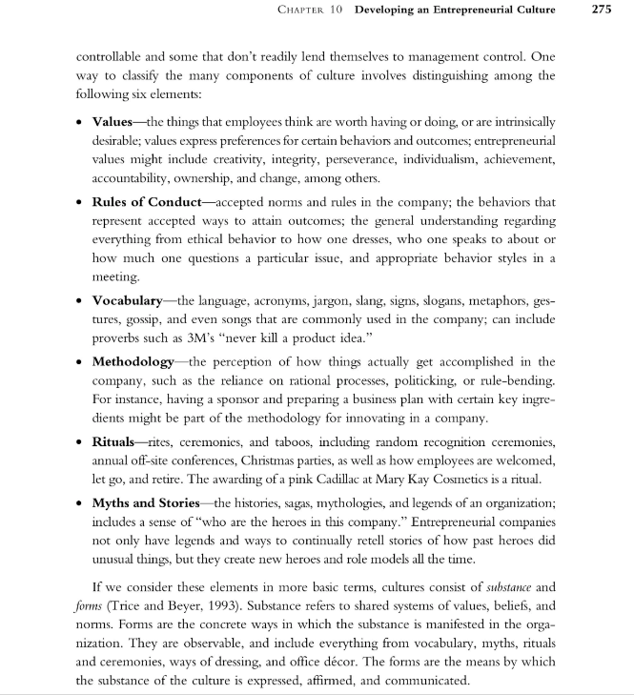

References
Morris, M. H., Kuratko, D. F., & Covin, J. G. (2010). Corporate entrepreneurship & innovation 3rd ed. Cengage Learning.

